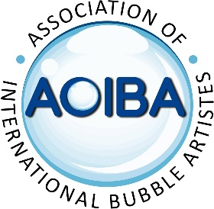
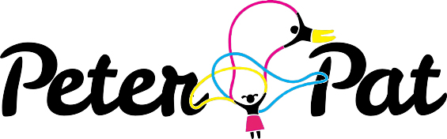
Registration Form
Bubble Fest Berlin, 24th April - 1st May 2023
Full Name: Address:
Contact Number: Contact Email:
AOIBA Member: Yes / No
Membership Status (Full member/Apprentice/Friend):
Any other people in your party:
What type of accomodation would you like:
- Caravan share in Mauer Park
- Hostel at walking distance from Mauer Park
- Would prefer to arrange your own accomodation
Which of the dates will you be attending?

What workshops/Talks would interest you:

Could you lead a talk/workshop (write details):

Would you like to bring your stage show to perform? If so please attach full technical-Rider, Show pack including company bio, marketing assets and links. You will need to submit expressions of interest for this option by 31st January 2023 at the latest.
Please email to: babbelarium@gmx.de and cc membership@aoiba.org
A registration fee may be required at a later stage
€20 for AOIBA Members
€40 for non-members
We look forward to seeing you there!

