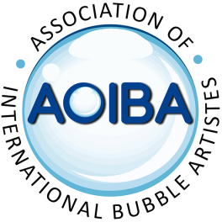

Monday 6th May 2024
International Bubble Blowing Day
To celebrate International Bubble Blowing Day on May 6th
AOIBA would like all of you to participate in the following project:
- Find a landmark that is local to you.
It doesn’t need to be internationally known, but it should be known in your local area.

- Take a camera and go make some bubbles at that landmark

- Take as many photos as you like making sure that YOU, the Bubbles and the LANDMARK are in the photo.

- Choose the best image making sure it’s in LANDSCAPE mode.

- Email your chosen photo to: may6@aoiba.org
Be sure to include the following information in your email:

Your name and or Stage Name
Your Country
Your state/Province
Your City/town
Name of the landmark in your photo

Email your submission to: May6@aoiba.org
If your file won’t send, try using this link: www.wetransfer.com
Please do not post your submission in the FB group

Deadline for submissions is APRIL 5TH 2024
Any submissions received after this date may not make it into the project.
All submissions will be made into a montage video and made available for ALL members to download at the end of April ready for you to post on your social media channels on May 6th
Information on how to do this will be posted at a later date.
Please do not post the montage video before May 6th.
Any questions please contact Damian Jay via a DM on FB or email Damian@damianjay.com

