Social Media Guide
  - AOIBA Social Media policy
Members guide for best practices when posting on and using AOIBA’s social Media channels
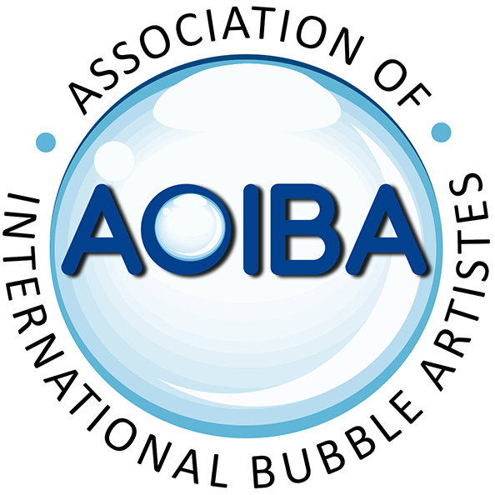
AOIBA’s Social Media guidelines
By following these guidelines (and the rules for individual platforms) AOIBA aims to create a respectful and productive social media experience that is a safe, positive, friendly, inclusive and warm environment where members can come together to discuss bubble related ideas, help, support assist and learn from one each other.

1 - AOIBA Code of Conduct:
Members are expected to treat one another, other performers, patrons and other whom they come into contact with: Honesty, Kindness, Integrity, Dignity and Respect.
While the sharing of knowledge and ideas is encouraged between members of the Association, ALL members are expected to treat intellectual property and copyright materials with respect and consideration. Seeking permission from, and giving credit to the originators where possible.

2 - Respect the privacy of others:
Being part of AOIBA and its online community is based on mutual trust. Content may at times be sensitive, personal, and or financial. Please be conscientious and respectful of others and do not share private information outside this group without express consent from those it concerns.

3 - Be kind and courteous:
Treat ALL members with respect, even if you disagree with them.
AOIBA welcomes debate and discussion on it social media channels and recognises that discussions can get ‘heated’. If a discussion starts to get out of hand, or you have an issue with another member, disengage from the conversation.
Try to resolve any conflict with members with them directly in private. If you still have issues, report the post to a member of the Admin team.
4 - No hate speech and or bullying: Celebrate our Differences.
AOIBA has a zero tolerance policy to hate speech, bullying and discrimination.
Such behaviour will result in posts being removed without warning and the offender may be banned from all AOIBA’s social media channels and possibly from AOIBA itself.
Facebook’s definition of hate speech is ‘anything that directly attacks people based on what are known as their “protected characteristics” — race, ethnicity, national origin, religious affiliation, sexual orientation, sex, gender, gender identity, or serious disability or disease’
Source: https://about.fb.com/news/2017/06/hard-questions-hate-speech/

If you experience or see any member subjected to any form of hate speech, Harassment and or Bullying, please report the post to Admins.
5 - Try to keep any discussions focused and light hearted: We welcome debate and discussion, but please keep comments relevant to the original post, and don't repeat the same message across multiple unrelated posts. Spam, and off-topic posts or comments may be removed.

6 – Moderation of social media channels:
Please be aware that posts made on the AOIBA social media platforms are also subject to individual platform rules As such, posts may be removed by individual platforms automatic algorithms as well as manually by any group Admin or moderators

Any breach of the above rules will be a matter for the channels Mods and or Admin team which may result in any offender receiving a warning and the removal of posts.
Repeat offenders along with any serious breach will be sent to Committee for their assessment.
This may result in the offender’s removal from any or all of AOIBA social media channels and for serious infractions, possible expulsion from AOIBA itself.
Members will have the right to appeal any Admin, Mod or Committee decision by following the Appeals process, found in the Complaints, Disputes and Resolutions guide on AOIBA.org

